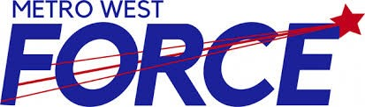

Metro West Force (INSERT TEAM NAME HERE)
Female Hockey Team

2021-2022 Hockey Season

To Whom It May Concern:

The 2021-2022 season for the (Insert team name here) Female Hockey Team has begun once again. We are asking for your support to help with the costs of running such a team through a Player Jersey Sponsor.

In order to help families alleviate the cost of tournament fees and ice time, we are providing local business with the opportunity to show their support for a young player by having a sponsor bar with your business name affixed to the player jersey for the entire 2020-2021 hockey season.

A player’s jersey can be sponsored for (insert $$ amount here) for each jersey (home/away) and receipts will be provided upon request. Please make your cheque payable to Insert team name here
The youth of our association thank you in advance for your consideration of this request.

Yours in hockey,

Insert Team name here

Team Representative _________________________________ Phone: _______________________

SPONSOR NAME: ___________________________________________________________

Thank you for your support!

Metro West Force

