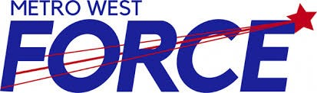

Metro West Force (INSERT TEAM NAME HERE)
Female Hockey Team

2023-2024 Hockey Season

To Whom It May Concern:

The 2023-2024 season for the (Insert team name here) Female Hockey Team is in full swing. We are seeking your financial support to help offset the costs of participation in this program through a Player Jersey Sponsor.

Jerseys can be sponsored through payment of $XXX. Your support will help alleviate the costs of both playing and developing in hockey. In exchange for your support, we will affix a sponsorship bar with your business name to a player’s jerseys for the entire 2023-2024 hockey season.

Please make your cheque payable to Insert team name here

The youth of our association thank you in advance for your consideration of this request.

Yours in hockey,

Insert Team name here

Team Representative _________________________________ Phone: _______________________

SPONSOR NAME: ___________________________________________________________

Thank you for your support!

Metro West Force

