**Metro West Force Female Hockey Association**

Evaluation

Process

The Metro West Force Hockey Association wants the entire evaluation process to be a positive experience for everyone involved.  It can be a stressful time for players and families so please become familiar with the information below, as we hope it will answer most of your questions.  
  
Metro West offers three levels of Hockey "AAA", "AA", "A" and "C" With three different levels of hockey, it is imperative for families to prepare for all possible outcomes.  Building unrealistic expectations prior to the process can have undesirable effects and spoil what could be a positive year for the player.

**To ensure the process runs as smoothly as possible, the following procedures MUST be adhered to:**

Any inquiries during and after the evaluations must be addressed to the MWF VP of Hockey Standards (contact info below). No other coach, evaluator, assistant or executive member will entertain any issues relating to individual players. **No phone calls or emails will be accepted until 24 hours have passed from the time of the placement posting. Should you call or email regarding placement of your child within the 24-hour period, your inquiry will not be heard.**

If the evaluation committee feels the matter needs further review, he/she will then consult with Metro West Executive. In extreme cases, the matter may be referred to members of Hockey Nova Scotia for advice prior to final decision by the Metro West President.  There will be no opportunity for individual player feedback on evaluation scores during or after the process.  
Harassing or threatening calls/e-mails will not be tolerated.  They will be reported to the Metro West Executive Committee and action will be taken immediately. Hundreds of hours have been dedicated by volunteers and outside professionals to provide a fair process to place players on the Metro West Force teams.  Please respect their time and feel free to thank them for providing the opportunity to ice competitive teams and develop young athletes.  
  
**It is the player’s responsibility to check the website for his/her next scheduled** evaluation **session.**All information will be posted on the website. We will attempt to provide all players at least 24 hours advance notice of their next ice session; however, this may not always be possible.

**Evaluation Policy**

1. An evaluation committee, consisting of the following members, will be established each year and will organize and coordinate the Evaluation process for MWF. If one of these roles or positions cannot be filled at the time the valuation committee is formed, the President may appoint any member in good standing to the Committee to replace a missing position.

a. VP Hockey Standards

b. VP Coaching

c- MWF Subcommittee for evaluations (could be made up of different members)

c. MWF Admin Lead

d. Evaluation Leads

The sole purpose of the evaluation committee is to ensure the processes and procedures within this document are followed. The evaluation committee will not be involved in the evaluation or the scoring process. This will be completed by all non- parent evaluators.

2. The evaluation committee will create the drills to be used for player’s evaluation. The drills used for player evaluations and standard player evaluation form will be documented and posted on the Team Selection section of the Association Website at least five (5) days prior to the start of a competitive Team Selection process. These drills will also be introduced during our MWF Conditioning camp sessions.

3. All individual player ratings and scores will be held confidential within the members of the evaluation committee. Under no circumstances will player ratings, scores, or placement relative to others be made public or disclosed to any individual not involved directly in the Team Selection process.

4. The only evaluation committee member with administrative access to any tools used for evaluations will be the MWF Admin Lead for the 2022 Evaluation process.

5. Player groups, regroups, or sorting can only be posted to the website after the evaluation Committee has approved the list to be posted.

6. All members who are involved in the evaluation process are required to declare any conflicts of interest prior to the beginning of the evaluation process. Evaluation committee members, MWF Executive members and employees who have a player involved will be removed from the process for the level at which their child plays.

**MWF Evaluator Guidelines**

1. Evaluators will be chosen by the evaluation committee with support from the VP Hockey Standards and the board of MWF.

2. An evaluation team will be established for each level consisting of an overall evaluation lead and a minimum of three (3) total evaluators.

3. Evaluation leads are responsible to ensure data integrity and consistency throughout the evaluation process.

4. Evaluators will use the Team Genius software and tablets to digitally record player scores during the evaluation process. All evaluators will be trained on how to properly use the Team Genius scoring system.

5. Players are identified in Team Genius by jersey color and number so no names are available to evaluators. Scores recorded in the Team Genius software are locked and not able to be adjusted following the conclusion of the evaluation session. Players are NOT permitted to wear private hockey program socks.

6. Evaluation teams will meet with the evaluation committee before evaluations begin to ensure consistency in the evaluation approach. The intent of the session is to review drill plans, expected skill demonstration and the nature of the evaluation.

7. Evaluators will sit separately, spread throughout the rink and will not have parent interaction during the evaluation session. Evaluators will remain for the entire 50-to-80-minute ice session.

8. There will be an adjusted evaluation process for goaltender evaluations. Goaltenders will have a minimum of two (2) qualified goalie professionals evaluating each session where the goaltenders are being evaluated and scored. Goaltender evaluations will not be recorded in Team Genius given the nature of the drills and evaluation method.

Available space, not near the evaluators, accessible from the second floor at the HRM 4Pad.

9. Parents are not permitted to engage with the evaluators or ask them questions, during or after evaluation sessions.

10. **Players will be evaluated based on the skills displayed during the on-ice sessions and not what group they begin the process in.**

**Expectations for Competitive Hockey**

We understand that many players are involved in other sports or activities and we would like to encourage that whenever we can.  However, hockey is a team sport and coaches and teammates expect that all parents and players will be committed to their respective hockey team.  Our coaches strive to deliver a fair play program that provides an opportunity for all players to develop.  For this to happen, we expect players to attend all practices and team sanctioned events.  Naturally, there will be situations that will lead to missed practices or events.  Please understand that players who regularly miss practices will also miss out on development opportunities which could lead to the potential for reduced playing time during games.

* **AA and AAA teams will have 2 or more on ice practices per week plus dryland training. Practices are not optional and players are expected to be there.**
* **A, AA and AAA teams may have multiple games per week.**
* **All MWF teams are part of provincial leagues (except U7 & U9), potentially covering associations from Cape Breton to Yarmouth. A may be in provincial leagues as well at some levels.**
* **A, AA and AAA teams may have additional fund raising requirements.**
* **Parents also need to form a team and each do their part to ensure the success of the team. Any parent that does not contribute to the teams financially agreed upon objectives and or fundraising efforts can have their child's playing privileges revoked.**
* **C Level hockey- will participate in 1-2 practices/ games per week.**  
    
  Please take note - If you and/or your player are not prepared to commit to the above, please advise the VP Hockey Standards immediately in order to allow another player the opportunity.

**Overview**

Non-biased evaluators from our female hockey evaluation committee will do the evaluation scoring.  Scores will be tabulated for each player to provide an overall score. This score will be used to in part to create balanced teams at each level.

At the AAA/AA/A level evaluations (mandatory for all players registered in the competitive evaluation process, each player will be scored at each session.  These scores will be the determining factor to determine releases to AA, A or C.

**Evaluation Process**

1. For the competitive evaluation process, MWF will use a ‘promotion’ model similar to that which is outlined in the Hockey Canada evaluation guide. This means that there will be a lot of player movement within different groups throughout the evaluation process.

2. ***Players will participate in a skill session and then reassigned according to these initial Stage 1 results. Throughout stages 2-4, there will be player movement within each of the three groups. There will be players moving up and down throughout the entire evaluation process.***

3. The level of teams fielded at each age group is based on registration numbers and demonstrated skill levels.

4. After the evaluation process, some players will be assigned to the AA, A and recreation levels.

The evaluation program is designed to evaluate the fundamental skill set of a player and give each player an opportunity to display these skills in game competition. Evaluators are not given players’ names; are encouraged not to share opinions; and are not provided with the other evaluators’ scores. Major discrepancies between evaluators are rare but will be investigated and if needed player’s history may be used. Players from other female Zone’s MHAs may be permitted to tryout with Metro West FHA based on HNSFC Regional Directors decisions that take into account the availability of teams in an area among other criteria.

**Goalies**

All goalies are to attend all their group sessions for skills and inter-squad games, along with separate goalie evaluations. Goalies will be assessed in in all player’s sessions and a separate goalie session.

**Team Selection & Player Scoring**

U11 Team selection will be made based on overall skill and not whether a player has signed up for forward or defense. The top evaluated players from the process will play at the highest level, regardless of the position.

**Stage 1: 60% for U11 25 % for U13-18**

(Skills session) (U11 will participate in 2 skills sessions)

All players will participate in a skills session.  Players will be scored on all drills completed in the session.  There will be skating, puck handling, 1 vs 1 and 2 vs 2 and small space battle drills.

***Players will be scored in compete level, decision-making, second efforts and creativity displayed for all drills.  Evaluator’s scores will be averaged and recorded*.**Scoring from Stage 1 sessions will help create the teams for the following sessions.  **Groupings will constantly change** prior to the Intrasquad games and may change between Intrasquad game 1, 2 and 3**.**

**Stage 2 - 4**

**40% for U11 75 % for U13-18**

(Inter-squad games)  **4 vs 4 and /or 5 vs 5**

The next session will consist of Intrasquad games played where, at times, the bench flow may be mixed up to give the evaluators a chance to see designated players in different match ups. All players will be given equal ice time.

**The evaluators will be looking for a player’s decision-making, second efforts and creativity as well as individual skating and puck skills.**

***MWF may add on additional evaluation sessions in order gain additional information for team selections.***

**Evaluation scoring, weighting and format**

|  |  |  |  |  |  |
| --- | --- | --- | --- | --- | --- |
|  | **TOTAL SESSIONS** | **STAGE 1**  SKILL SESSION, BATTLE DRILLS  3VS 3, 2VS 2 | **SCORING WEIGHT**  **STAGE 1** | **STAGE 2-4**  **EXHIB. GAMES (POSS. 4 VS 4 ,**  **5 VS 5)** | **SCORING WEIGHT**  **STAGE 2- 4** |
| U9 | 4 | 2 SESSIONS | 60% | 2 SESSIONS | 40% |
| U11 | 4 | 1 SESSION | 25% | 3 SESSIONS | 75% |
| U13 | 4 | 1 SESSION | 25% | 3 SESSIONS | 75% |
| U15 | 4 | 1 SESSION | 25% | 3 SESSIONS | 75% |
| U18 | 4 | 1 SESSION | 25% | 3 SESSIONS | 75% |

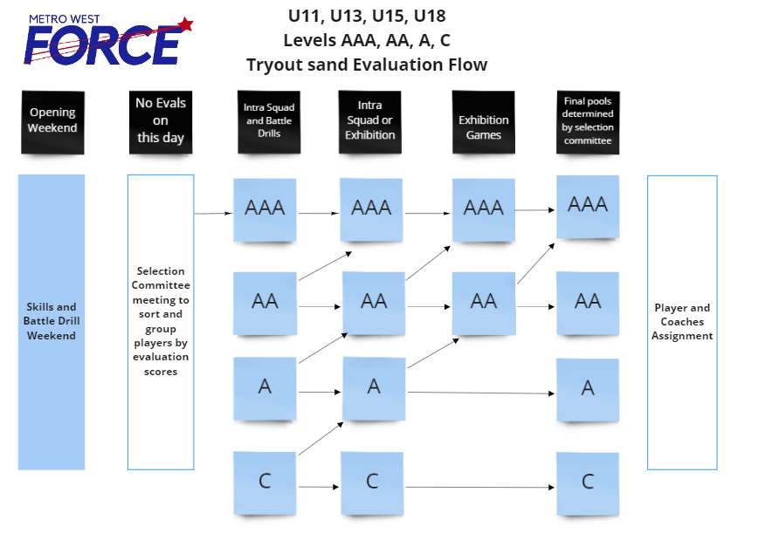

**The goal of the evaluation process is to determine the best level where each player should play with MWF. The MWF evaluation committee reserves the right to change the format of the evaluation process at any time in order to gather further information that will aid in the selection process. E.g. changing a session from 4 vs 4 to 5 vs 5 or half ice versus full ice. Parents cannot request a position change after the commencement of evaluations.**

Once the required number of players are confirmed, the MWF Head Coaches an Assistant Coaches can be confirmed. Team assignments will be decided by a MWF selection Committee in consultation will the head coaches.  No team draft will occur.

Some player releases to the AA/A/C level, as well as players being selected to the AAA levels, will occur after Stage 3.

**Special Note for all Players**

For U13-U18 divisions, players will be required to declare a position prior to evaluations.  Metro West Executive reserves the right to meet with players and their families.

**Evaluation Jersey**

Failure to return a player’s jersey will result in a $50 charge that must be paid before the player is named to a team and will result in the player’s score not being counted for the session

**U11 / U13 / U15 Recreation Evaluation Process**

At the recreation level, our goal is to create equally balanced C teams where players have the opportunity for competitive play and skill development.

1. An evaluation process will be conducted to assess players who have registered for recreational hockey to determine skill level and assist with the creation of balanced teams. Players will be evaluated by evaluators selected for the MWF evaluation process.

2. Players at the U11, U13, U15 levels will participate in two sessions – one skill session (skating and puck drills) and one intra-squad game. Players will be evaluated during each session and an overall score obtained for each player.

3. Following completion of the assessment process, players will be ranked from 1 to X based on their evaluation scores and this ranking will be used for a draft process with assigned recreational coaches to create balanced teams.

**Injured Players**

Inevitably and unfortunately, some players become injured during the process and/or sometimes before evaluations begin. This can result in a very difficult situation for everyone involved (injured players, parents, players this player is competing with, evaluators and Zone Executive).  When this happens, we attempt to place the player at the appropriate level base on a number of qualitative factors:

* Where did the player play last season?
* Spring Identification sessions if completed
* How did he/she develop during that year?
* How was the injured player’s performance at the end of the previous season relative to the other players on his/her team?
* The player may be compared to another undisclosed, like-skilled player so that a score can be given and used in tabulating a final score.
* Discussion with prior coaches for other qualitative factors.
* In all, a complete effort for fairness of all involved is the goal.

**Injured players must be able to return to play by Dec. 1st to be placed on a competitive team.**

**Missed session**

If a player misses a scheduled session without prior approval from the MWF VP of Hockey Standards, they will be given a score of **'0'** for that session, which, in turn will be used in the final scoring.  Requesting to miss a session should be very rare and in exceptional circumstances only. Each situation would be considered independently, as each player and circumstance is individually different.

**Appeals Process**

Should a family wish to appeal the level their child has been assigned, they may do so by request through the president@metrowestforce.com email address.

The only appeals that are acceptable are appeals based on the process described in this document not being followed. Appeals related to evaluation scores and comparison from one player to another will not be entertained. Upon submission of an appeal, it will be reviewed by the Evaluation Committee. The committee shall contact the Complainant with their decision/solution. If the Complainant does not agree with the decision/solution of the Evaluation Committee, then an Investigative Committee will be struck to review the details of the appeal. The Committee, led by the President will include a Divisional coordinator and 1 other member. No Investigative Committee member may be in a conflict of interest. The results of the committee review will be shared with the appellant and findings will be binding.

**Contact Information**  
  
Mike Almond  
MWF VP Hockey Standards  
[vphockeystandards@metrowestforce.com](mailto:vphockeystandards@metrowestforce.com)  
   
Tim Sheppard  
MWF President  
[president@metrowestforce.com](mailto:president@metrowestforce.com)